COVID-19 CDC GUIDELINES

When to Quarantine
https://www.cdc.gov/coronavirus/2019-ncov/if-you-are-sick/quarantine.html

Quarantine is used to keep someone who might have been exposed to COVID-19 away from others. Quarantine helps prevent spread of disease that can occur before a person knows they are sick or if they are infected with the virus without feeling symptoms. People in quarantine should stay home, separate themselves from others, monitor their health, and follow directions from their state or local health department.
Quarantine or isolation: What's the difference?

Quarantine keeps someone who might have been exposed to the virus away from others.
Isolation keeps someone who is infected with the virus away from others, even in their home.

Who needs to quarantine?
People who have been in close contact with someone who has COVID-19—excluding people who have had COVID-19 within the past 3 months.
People who have tested positive for COVID-19 do not need to quarantine or get tested again for up to 3 months as long as they do not develop symptoms again. People who develop symptoms again within 3 months of their first bout of COVID-19 may need to be tested again if there is no other cause identified for their symptoms.
What counts as close contact?
- You were within 6 feet of someone who has COVID-19 for a total of 15 minutes or more
- You provided care at home to someone who is sick with COVID-19
- You had direct physical contact with the person (hugged or kissed them)
- You shared eating or drinking utensils
- They sneezed, coughed, or somehow got respiratory droplets on you
Steps to take
Stay home and monitor your health
- Stay home for 14 days after your last contact with a person who has COVID-19
- Watch for fever (100.4◦F), cough, shortness of breath, or other symptoms of COVID-19
- If possible, stay away from others, especially people who are at higher risk for getting very sick from COVID-19

https://www.cdc.gov/coronavirus/2019-ncov/if-you-are-sick/end-home-isolation.html

For Anyone Who Has Been Around a Person with COVID-19
Anyone who has had close contact with someone with COVID-19 should stay home for 14 days after their last exposure to that person.
However, anyone who has had close contact with someone with COVID-19 and who meets the following criteria does NOT need to stay home.
- Has COVID-19 illness within the previous 3 months and
- Has recovered and
- Remains without COVID-19 symptoms (for example, cough, shortness of breath)

I tested positive for COVID-19 but had no symptoms
If you continue to have no symptoms, you can be with others after 10 days have passed since you had a positive viral test for COVID-19. Most people do not require testing to decide when they can be around others; however, if your healthcare provider recommends testing, they will let you know when you can resume being around others based on your test results.
If you develop symptoms after testing positive, follow the guidance above for “I think or know I had COVID-19, and I had symptoms.”

I think or know I had COVID-19, and I had symptoms
You can be around others after:
- 10 days since symptoms first appeared and
- 24 hours with no fever without the use of fever-reducing medications and
- Other symptoms of COVID-19 are improving*
*Loss of taste and smell may persist for weeks or months after recovery and need not delay the end of isolation​
Most people do not require testing to decide when they can be around others; however, if your healthcare provider recommends testing, they will let you know when you can resume being around others based on your test results.
Note that these recommendations do not apply to persons with severe COVID-19 or with severely weakened immune systems (immunocompromised). These persons should follow the guidance below for “I was severely ill with COVID-19 or have a severely weakened immune system (immunocompromised) due to a health condition or medication. When can I be around others?”

When to start and end quarantine
You should stay home for 14 days after your last contact with a person who has COVID-19.
For all of the following scenarios, even if you test negative for COVID-19 or feel healthy, you should stay home (quarantine) since symptoms may appear 2 to 14 days after exposure to the virus.
See scenarios below to determine when you can end quarantine and be around others.

Scenario 1: Close contact with someone who has COVID-19—will not have further close contact
I had close contact with someone who has COVID-19 and will not have further contact or interactions with the person while they are sick (e.g., co-worker, neighbor, or friend).
Your last day of quarantine is 14 days from the date you had close contact.
Date of last close contact with person who has COVID-19 + 14 days= end of quarantine
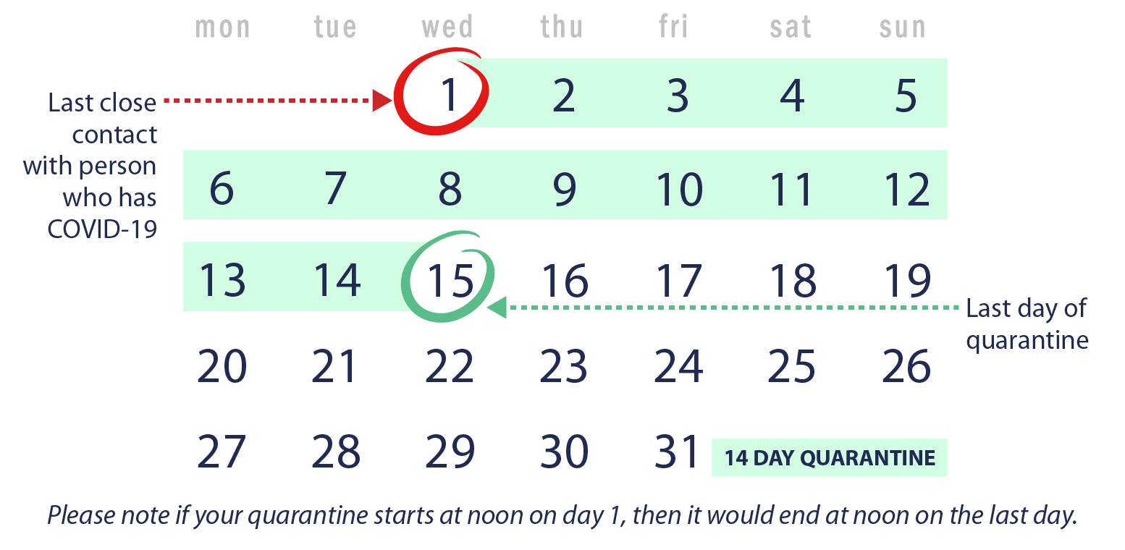

Scenario 2: Close contact with someone who has COVID-19—live with the person but can avoid further close contact
I live with someone who has COVID-19 (e.g., roommate, partner, family member), and that person has isolated by staying in a separate bedroom. I have had no close contact with the person since they isolated.
Your last day of quarantine is 14 days from when the person with COVID-19 began home isolation.
Date person with COVID-19 began home isolation + 14 days = end of quarantine
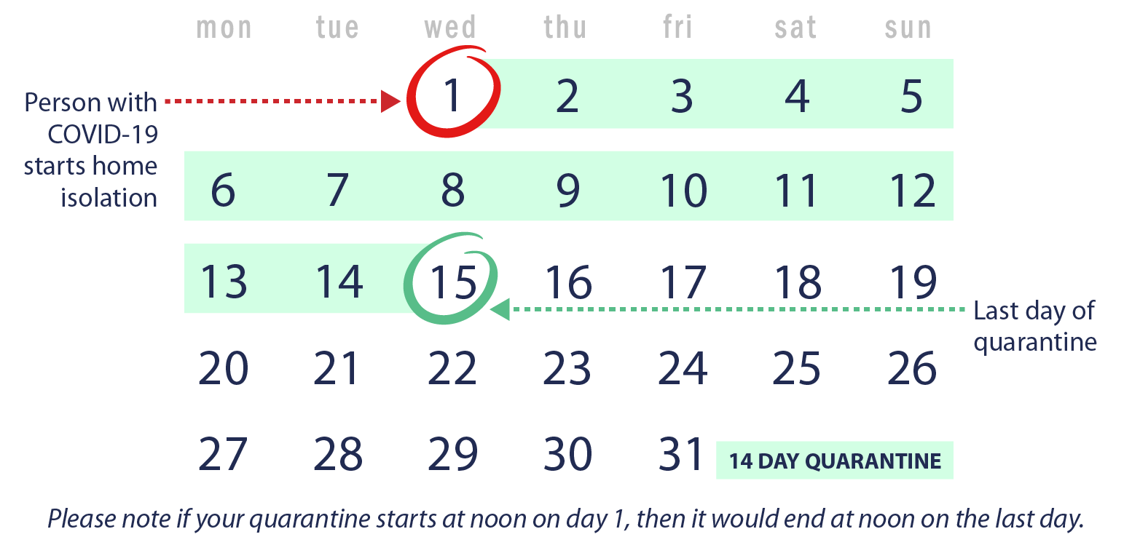

Scenario 3. Under quarantine and had additional close contact with someone who has COVID-19
I live with someone who has COVID-19 and started my 14-day quarantine period because we had close contact. What if I ended up having close contact with the person who is sick during my quarantine? What if another household member gets sick with COVID-19? Do I need to restart my quarantine?
Yes. You will have to restart your quarantine from the last day you had close contact with anyone in your house who has COVID-19. Any time a new household member gets sick with COVID-19 and you had close contact, you will need to restart your quarantine.
Date of additional close contact with person who has COVID-19 + 14 days = end of quarantine
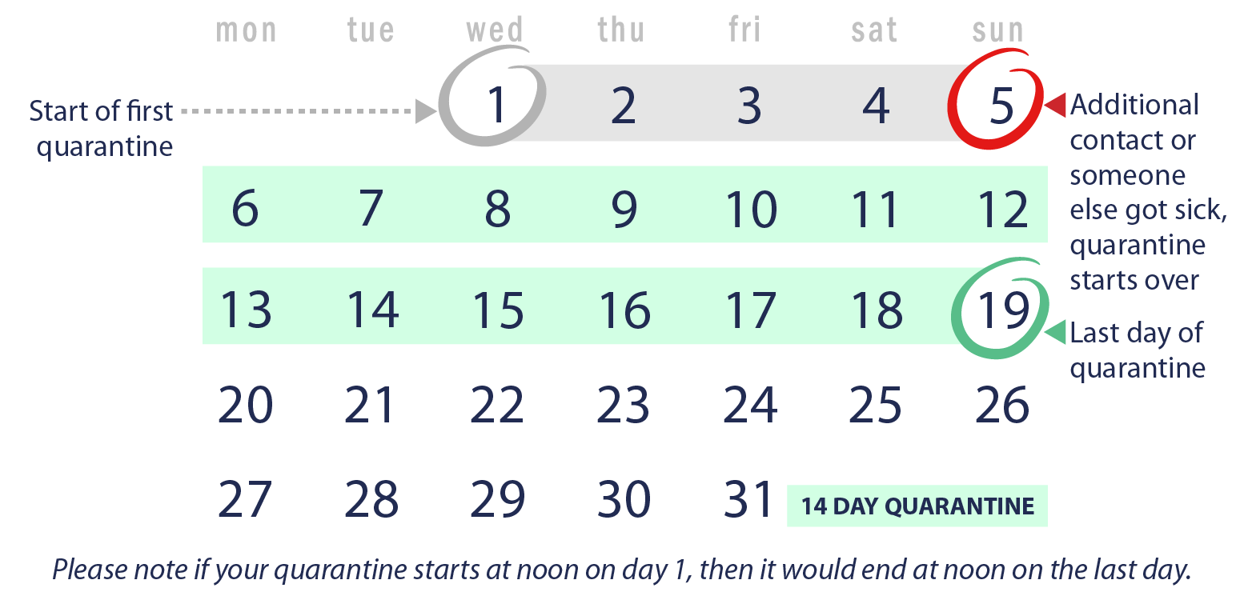

Scenario 4: Live with someone who has COVID-19 and cannot avoid continued close contact
I live in a household where I cannot avoid close contact with the person who has COVID-19. I am providing direct care to the person who is sick, don’t have a separate bedroom to isolate the person who is sick, or live in close quarters where I am unable to keep a physical distance of 6 feet.
You should avoid contact with others outside the home while the person is sick, and quarantine for 14 days after the person who has COVID-19 meets the criteria to end home isolation.
Date the person with COVID-19 ends home isolation + 14 days = end of quarantine
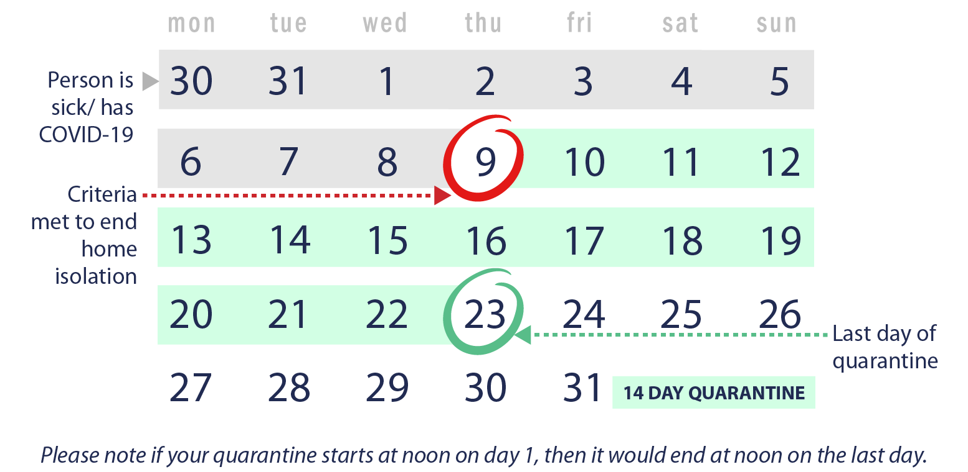
Top of Page
Last Updated Sept. 10, 2020
Content source: National Center for Immunization and Respiratory Diseases (NCIRD),

