Step 1 – Click the link in your email.
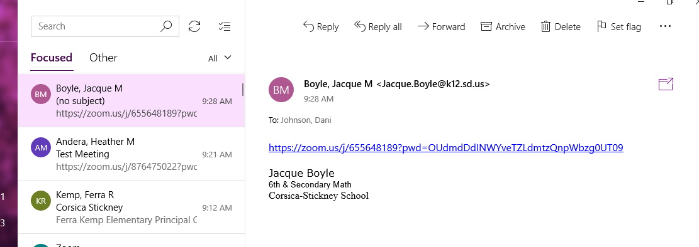

Step 2 – Go to your browser

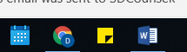

Step 3 – Wait – When you see the screen below. Click “Click Here”
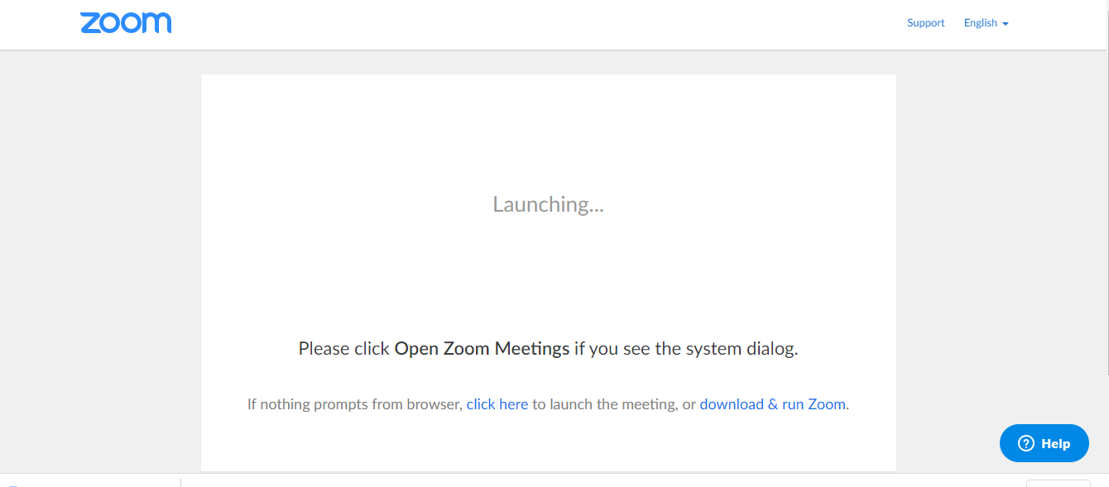

Step 4 – Click “Join from your browser”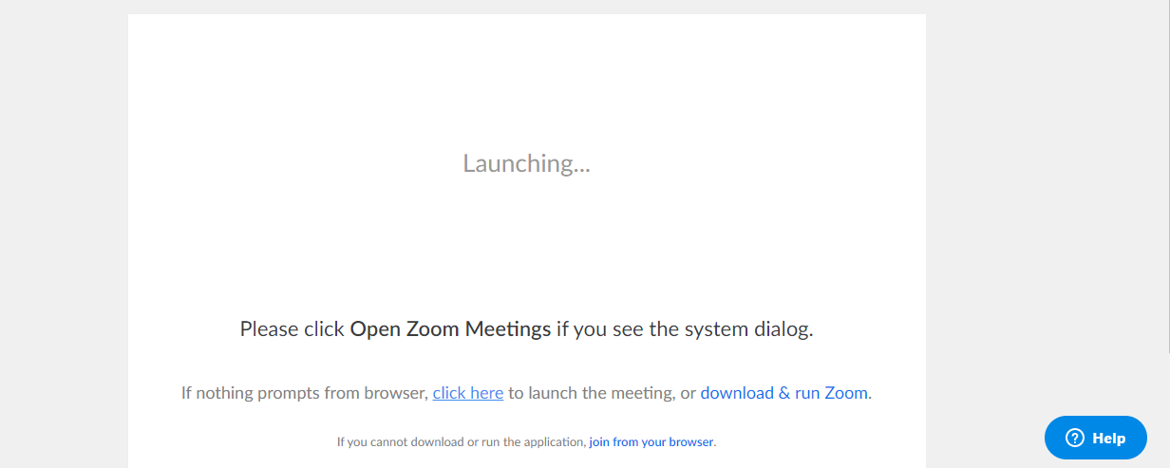

Step 5 – Click Join
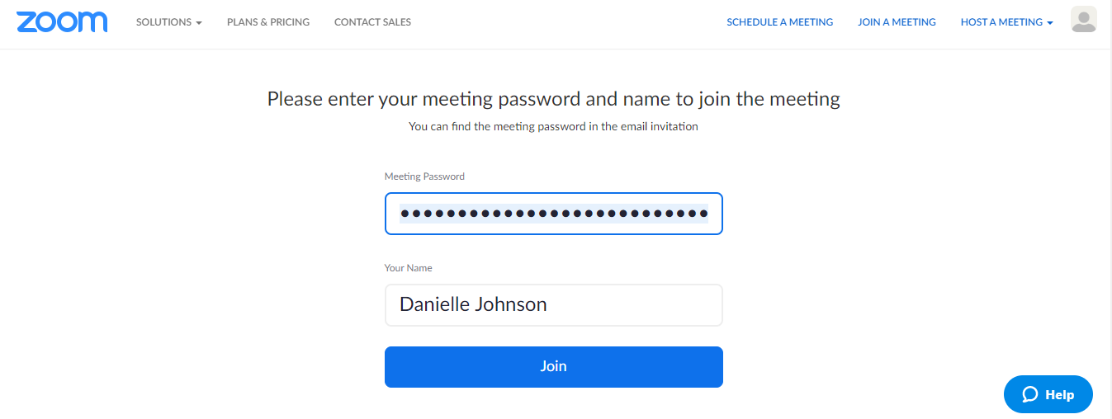

Step 6 – Join Audio by Computer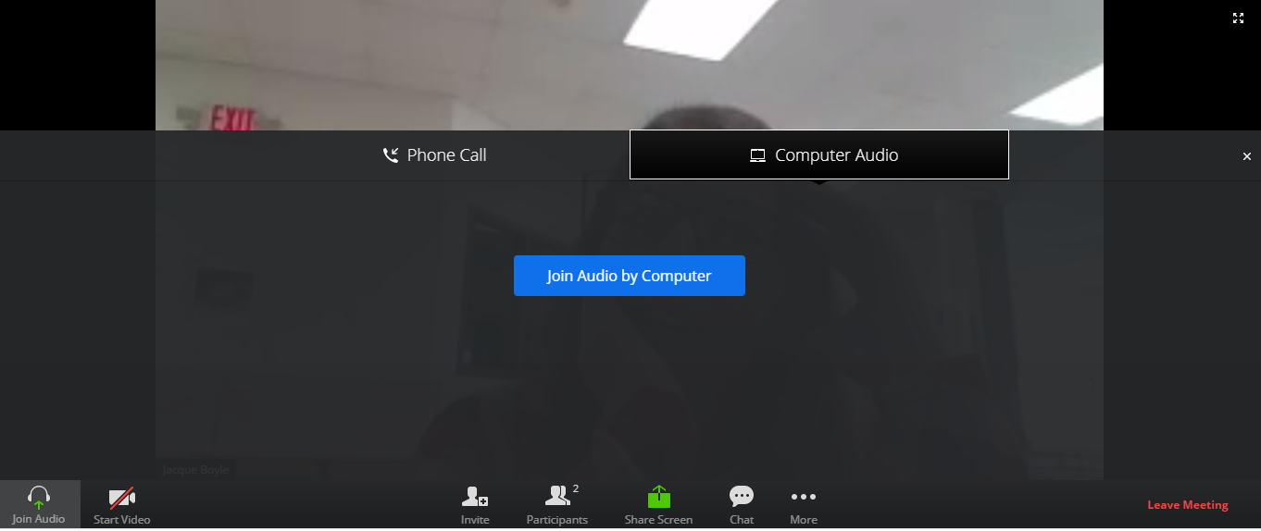
Step 7 – Click “Start Video”
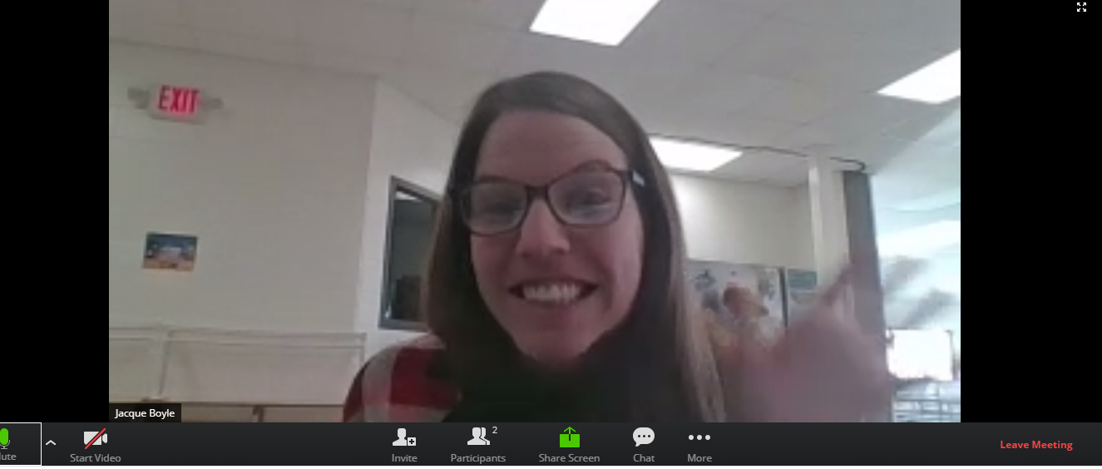

Step 8 – Say hi
